**Reading**



**1-Read the technology guide about computer assembly. Then, choose the correct answers.**

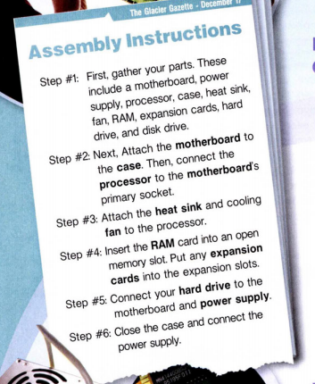

**1 What is the guide mostly about?**

A putting together a computer

B problems with computer parts

C uses of expansion cards

D repairing a broken computer

**2 When should the hard drive be installed?**

A Step #1

B Step #3

C Step #5

D Step#6

**3 According to the guide, what is NOT an assembly step?**

A collecting parts

B opening the case

C connecting the drives

D installing the RAM card

**Vocabulary**

**1-Match the words (1-6) with the definitions (A-F).**

1 _ heat sink

A a slotted board with circuits and ports

B a short term, quick memory source

C a part used to cool the processor

D a part used to store large amounts of data

E a part used to increase a computer's functions

F a part that completes tasks for the computer

2 _RAM

3 _ expansion card

4 _ processor

5 _ hard drive

6 _ motherboard

**2-Write a word that is similar in meaning to the underlined part.**

1-Spinning blades keep the computer from overheating. f _ _

2 The electrical source directs power throughout the computer. _ _ w _ r _ _ p p _ _

3 Joey purchased a protective bag for his computer. c _ _ _

4 Can the coded disk reader play DVDs? d _ _ _ d _ _ v_

**Listening **

**1-Listen to a conversation between a technology support specialist and a customer.**

**1- Listen and choose the correct option.**

**Support Specialist**: 1- TECHNOLOGY / CUSTOMERS Support, Ivan speaking. How can I help?

**Customer:** I have an old 2- HARDWARE / HARDRIVE and need help taking it out.

**Support Specialist**: Okay. 3- UNPLUG / PLUG IN the connection to the power supply first.

Then, disconnect the 4- POWER SUPPLY / MOTHERBOARD cable.

**Customer**: Which one is the 5- POWER SUPPLY / MOTHERBOARD?

**Support Specialist**: It's the smaller black 6- BOX / CABLE in the corner.

**Customer**: I'm 7- DISCONNECTING / UNPLUGGING both. What's next?

**Support Specialist**: Next, take out the two small 8 – SCREWS / CABLES.

They fasten the hard drive to the 9- CASE / BOX.

**Customer**: I see, and then it slides out. Thanks!

**2- Mark the statements as true (T) or false (F).**

1 _ The woman replaces the disk drive.

2 _ The woman disconnects the power supply first.

3 _ The hard drive connects to the motherboard.

4 - The woman fastens the 2 screws .

5- The case slides out .